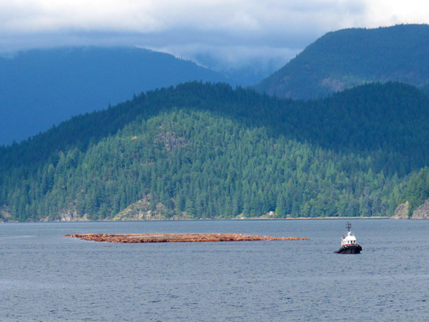
Stand Development Monitoring
Sunshine Coast TSA Data Summary

THIS SUMMARY IS BASED ON DATA FROM LESS THAN 30 SURVEYED POLYGONS. THE RESULTS PRESENTED ARE CONSIDERED PRELIMINARY.

This summary is from polygons surveyed in the Sunshine Coast TSA in 2012. This summary is an example of the variety and depth of information that is possible to extract from SDM data.

Currently, SDM field survey data is entered into an EXCEL spreadsheet template. This template provides an individual polygon data summary for immediate use. These spreadsheets are then loaded into the SDM ACCESS database. The database can be queried to produce an aggregated data summary like this one that includes data from multiple polygons within a TSA. The queries can be adjusted to extract data in various combinations depending on the user’s needs.

This summary is not an analysis; it provides limited interpretation of the data. Reports examining specific questions regarding productivity or that seek to explain trends and other behaviours can be constructed based on this data along with the use of other supporting tools or evidence.

Provincial and regional Forest Health and Silviculture staff can be asked to help with the interpretation of the information presented in the summaries and in the creation of more detailed reports.

Your input as comments and suggestions are needed to further develop these summaries. Please contact Harry.Kope@gov.bc.ca and provide your suggestions for improvement.

STAND DEVELOPMENT MONITORING – SUNSHINE COAST TSA Summary
Purpose and Audience – Data summaries can help statutory decision makers and operational foresters make informed decisions on stand development, TSR data package inputs, FSP renewals, and FFT activity priorities. They provide information on the growth and health of managed stands. The Forest and Range Evaluation Program (FREP) in conjunction with the provincial forest health program have designed an evaluation protocol (Stand Development Monitoring - SDM) that assesses the condition of post-free-growing managed stands by measuring stand attributes and the impact of biotic and abiotic damaging factors on stand health to help determine whether these free-growing stands are meeting productivity expectations.
NOTE – This report provides summary information obtained from surveyed polygons. Inferences from this summary should be made cautiously.
This summary includes data on: Sample Summary Forest Health Stand Density Species Composition Site Index
SAMPLE SUMMARY
Polygon and polygon population attributes, and numbers and percentages of sampled live trees.

A1 – number of polygons summarized
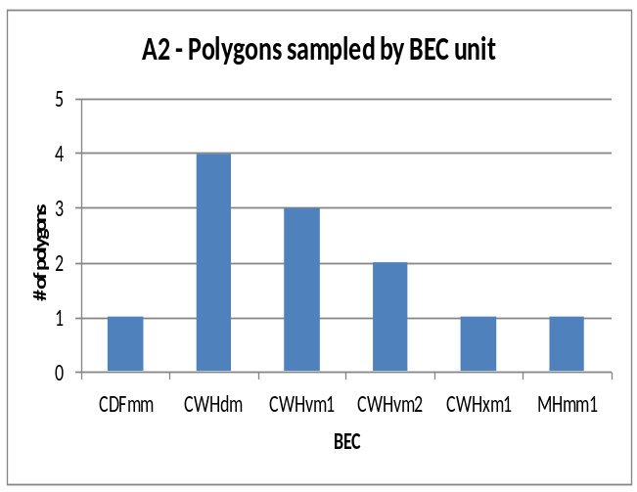
Survey year: | 2012
DSC | 12

A3 - sampled polygon attributes
Attribute | nª | Mean | SD^{b} | Range
Polygon net area (ha) | 12 | 14.3 | 10.4 | 5 – 40
Stand Age (yrs) | 11 | 31.3 | 4.0 | 26 – 38
Harvest to Declaration (yrs) | - | - | - | -
Planting to Declaration (yrs) | - | - | - | -
Declaration to SDM (yrs) | - | - | - | -
ª. Differing ‘n’ values indicate missing information for some polygons.
^{b}. SD - Standard Deviation

A4 - sample population coverage
TSA  polygon population  (n) | Total polygon population  area (ha) | Number Polygons  ≥5 ha  (n) | Population polygon area  ≥5 ha  (ha) | Number of polygons sampled  (n) | Sampling intensity by number of polygons | Area  sampled  (≥5 ha)  (ha) | Sampling intensity by area

A5 - number and percentage of sampled total live trees
Tree species: | Ba | Bg | Cwc | Dr | Fdc | Hm | Hwc | Mb | Pw | Se | Ss | Vb | Yc | Total
Number | 212 | 6 | 647 | 69 | 331 | 56 | 743 | 8 | 1 | 23 | 11 | 128 | 115 | 2350
Percent | 9 | <1 | 28 | 3 | 14 | 2 | 32 | <1 | <1 | 1 | <1 | 5 | 5 | 100

X1 - Tree Species Abbreviations
Ba – Amabilis Fir Mb – Bigleaf Maple
Bg – Grand Fir Pw – Western White Pine
Cwc – Western Red Cedar (coastal) Se – Engelmann Spruce
Dr – Red Alder Ss – Sitka Spruce
Fdc – Douglas-fir (coastal) Vb – Bitter Cherry
Hm – Mountain Hemlock Yc – Yellow Cedar
Hwc – Western Hemlock (coastal)
FOREST HEALTH
Forest Health is assessed using the SDM damage criteria for mid-rotation stands (see Appendix 1). The damage criteria establish forest health threshold tolerances identifying unacceptable and damaged trees. In the Sunshine Coast TSA: the pathogen most recorded was Armillaria root disease (DRA); the insect was White Pine Weevil (IWS); the animal was Elk (AE); and the abiotic damage was Tree Competition (VT).
B1 – mean stems per ha by forest health status
X2 – tree layers
Layer 1: >12.5 cm dbh
Layer 2: 7.5 to 12.5 cm dbh
Layer 3: >1.3 m in height to 7.49 cm dbh
Live Acceptable Trees (sph) | Live Unacceptable Trees (sph) | Dead Unacceptable Trees (sph) | Total Stemsª (sph)
3750 | 167 | 185 | 4102
ª For forest health purposes total stems equals all live trees plus all dead trees.
X3 – forest health abbreviations
DRA –Armillaria root disease VT – Tree competition U – Unknown
DRL – Laminated root disease NY – Snow press
DS – Stem disease ND - Drought
IWS – White pine weevil VH – Herbaceous competition
AE – Elk NGC – Frost crack
A - Animal NW - Wind throw
B2 - forest health factors detected
(Number of plots) with a specific forest health factor. Plots = 120
Pathogen DRA (9) DRL (1) DS (1)
Insect IWS (1)
Animal AE (2) A (1)
Abiotic VT (29) NY (21); ND (4) VH (2) NGC (1) NW (1)
Unknown U (28)

B3 - incidence of forest health factor by bec
BEC | Tree Layer | Total Stems | Acceptable Trees |  |  | Unacceptable Trees |  |  |  |  |  | Percent incidence^{c} of Forest Health Factor^{d} for each tree layer
 |  |  |  |  |  | Live |  |  | Dead
BEC | Tree Layer | Total Stems | n | (%^{b}) | n |  | (%^{b}) | n |  | (%^{b}) | DRA |  | DRL | DS | IWS | AE | A | VT | NY | ND | VH | Other | U
CDFmm | 1
 | 2
 | 3
CWHdm | 1
 | 2
 | 3
CWHvm1 | 1
 | 2
 | 3
CWHvm2 | 1
 | 2
 | 3
CWHxm1 | 1
 | 2
 | 3
MHmm1 | 1
 | 2
 | 3
^{b} Percent based on total stems (live and dead); ^{c} Percent incidence of the total stems by layer for each FHF; ^{d} Only the top FHF are listed, the Other column contains the minor FHF not listed.

FOREST HEALTH (continued)
B4 - incidence of forest health factor by tree species
Tree Species | Tree Layer | Total Stems | Acceptable Trees |  |  | Unacceptable Trees |  |  |  |  |  | Percent incidence^{c} of Forest Health Factor^{d} for each tree layer
 |  |  |  |  |  | Live |  |  | Dead
Tree Species | Tree Layer | Total Stems | n | (%^{b}) | n |  | (%^{b}) | n |  | (%^{b}) | DRA |  | DRL | DS | IWS | AE | A | VT | NY | ND | VH | Other | U
Ba | 1
 | 2
 | 3
Cwc | 1
 | 2
 | 3
Dr | 1
 | 2
 | 3
Fdc | 1
 | 2
 | 3
Hwc | 1
 | 2
 | 3
Vb | 1
 | 2
 | 3
Yc | 1
 | 2
 | 3
ª Percent based on total stems (live and dead); ^{b} Percent incidence of the total stems by layer for each FHF; ^{c} Only the top FHF are listed, the Other column contains the minor FHF not listed.

STAND DENSITY
To produce a free-growing crop of trees a stand is managed to the target stocking level of well-spaced, preferred and acceptable species. Over time, changes in stand density may reflect tree competition, mortality due to pests, stand treatments, natural ingress or other influences.
C1 - number of polygons with changes to stand density
Change in Total Stand Density  Total Trees (n= 12) |  | Change in Stocking Density  Well-Spaced Trees (n= 12)
Decreasing |  | Decreasing
Increasing |  | Increasing
 |  | Unchanged

C2 - stand density attributes by bec – pre-sdm and at sdm
 |  | CDFmm |  |  | CWHdm |  | CWHvm1 |  | CWHvm2 |  |  | CWHxm1 |  |  | MHmm1 |  |  | ALL
 |  | N | Mean (sph) | N |  | Mean (sph) | N | Mean (sph) | N | Mean (sph) | N |  | Mean (sph) | N |  | Mean (sph) | N |  | Mean (sph)
Total Density pre-SDM (sph)
Total Density at SDM (sph)
Change in Total Density (sph)
Change in Total Density (%)
WS density pre-SDM (sph)
WS density at SDM (sph)
Change in WS density (sph)
Change in WS density (%)
FG density pre-SDM(sph)
FG density at SDM (sph)

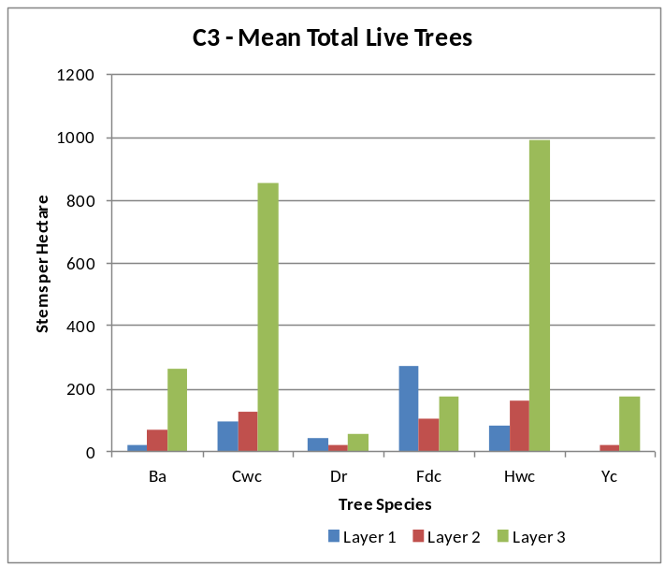

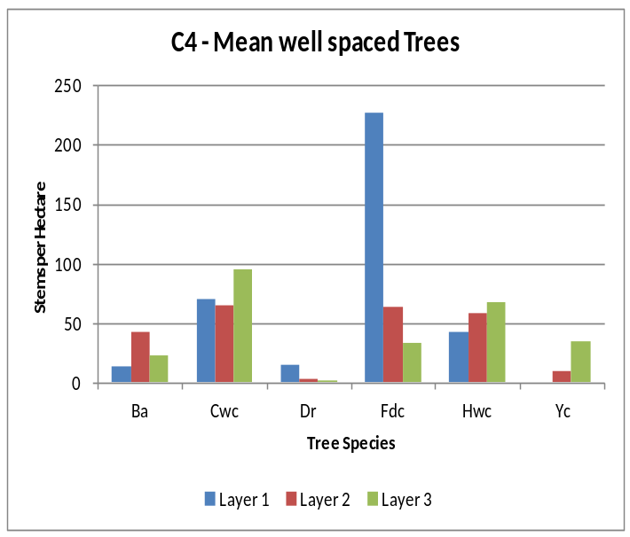

SPECIES COMPOSITION
Inventory labels are condensed representations of several stand attributes that describe conditions at the time of assessment. These attributes include leading, secondary and minor tree species by percentage class (usually rounded to the nearest 10%), average age and height of the dominant and co-dominant trees, a site index estimate, an estimate of crown closure, and the total trees per hectare. Inventory labels provide inputs used by the TASS stand model and by timber supply analysts projecting future stand development for timber supply purposes.
D1 - change in leading species between pre-sdm and sdm assessments
Pre-SDM
CDFmm CWHdm CWHvm1 CWHvm2 CWHxm1 ALL
At SDM

Total
(Shaded values indicate those polygons where the leading species has NOT changed)
(In this TSA, no change in leading species was found in X (%) of the X polygons sampled.)

D2 – number of trees, by species and layer, contributing to mean basal area
 | Number of Trees |  |  |  |  | Mean Polygon BA (m²/ha)
Tree spp. | Layer 1 |  | Layer 2 |  | All | Layer 1 |  | Layer 2 |  | All
 | Live | Dead | Live | Dead |  | Live | Dead | Live | Dead
Ba | 12 | - | 42 | - | 54 | 0.64 | - | 0.52 |  | 1.16
Cwc | 57 | - | 74 | - | 131 | 2.62 | - | 0.91 |  | 3.52
Dr | 24 | - | 9 | - | 33 | 1.26 | - | 0.11 |  | 1.37
Fdc | 163 | 2 | 55 | 4 | 224 | 8.70 | 0.23 | 0.85 | 0.05 | 9.55
Hwc | 49 | 1 | 99 | - | 149 | 2.30 | 0.04 | 1.23 |  | 3.53
Minor spp. | 9 | - | 31 | 1 | 40 | 0.58 | 0.27 | 0.37 | 0.01 | 0.96
Total | 317 | 3 | 309 | 5 | 631 | 15.82 | 0.28 | 3.93 | 0.06 | 20.09
% within layer | 99.1 | 0.9 | 98.4 | 1.6 |  | 98.3 | 1.7 | 99.2 | 0.8
(Minor spp. include: Bg, Hm, Se, Ss, Vb and Yc).

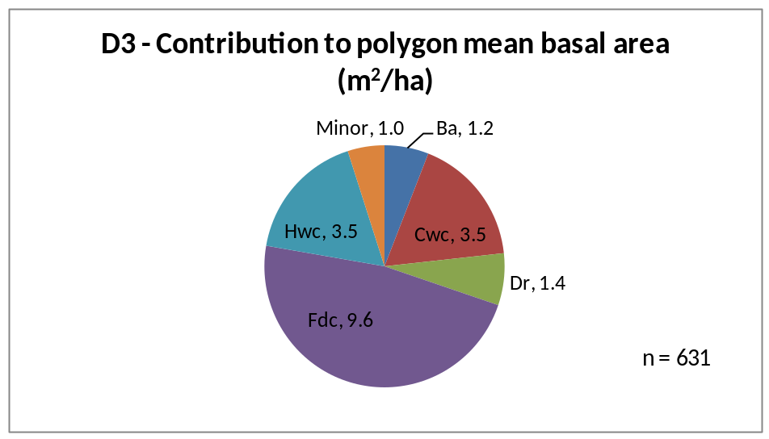

SITE INDEX
Site index is estimated using the growth intercept method. These estimates are the mean values of all available trees for that species in a BEC unit. Many stands do not have site index estimates recorded prior to the SDM survey.
E1 - mean site index estimate for dominant conifer species
 | Ba |  | Cwc |  | Fdc |  | Hwc |  | Total
BEC | N | Mean | N | Mean | N | Mean | N | Mean | N
CDFmm | - | - | - | - | 6 | 36.3 | - | - | 6
CWHdm | - | - | 5 | 28.8 | 29 | 38.8 | 4 | 32.1 | 38
CWHvm1 | 2 | 31.3 | 3 | 25.5 | 14 | 35.5 | 2 | 27.7 | 21
CWHvm2 | 11 | 19.0 | - | - | 9 | 34.9 | - | - | 20
CWHxm1 | - | - | - | - | 9 | 34.9 | - | - | 9
MHmm1 | 2 | 19.8 | - | - | - | - | 3 | 16.5 | 5
 | 15 | 20.8 | 8 | 27.6 | 58 | 37.1 | 16 | 23.8 | 99

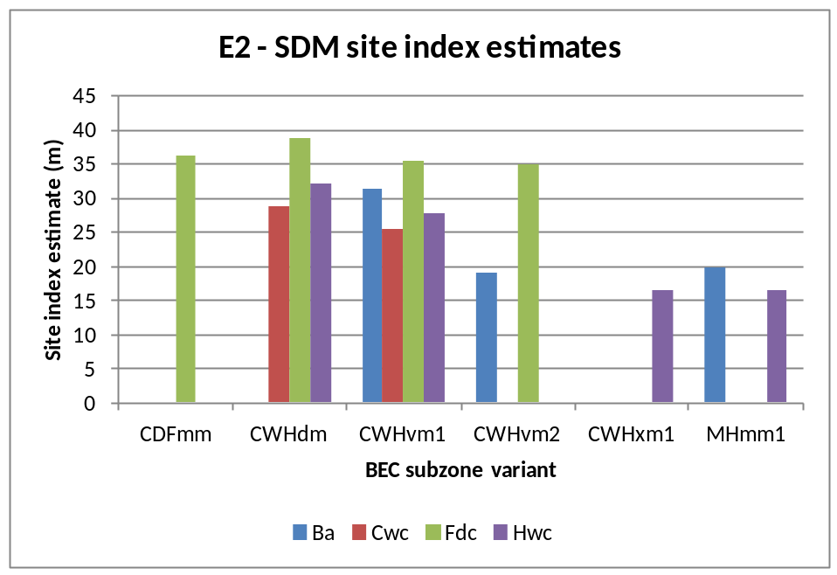

APPENDIX 1
BEC codes - http://www.for.gov.bc.ca/hre/becweb/index.html
Conifer pest codes - http://www.for.gov.bc.ca/hfp/health/fhdata/FS747%20conifer%2020111003.pdf
Conifer Tree Species codes http://www.for.gov.bc.ca/his/results/webhelp/index.htm
Deciduous pest codes - http://www.for.gov.bc.ca/hfp/health/fhdata/FS747%20deciduous%2020111003.pdf
SDM damage criteria - http://www.for.gov.bc.ca/hfp/silviculture/Surveys/SDM_Damage_Criteria_Feb_12_2010(2).pdf
SDM field cards - http://www.for.gov.bc.ca/ftp/HFP/external/!publish/FREP/indicators/FS%201357-SDMCard%20March%2012%2009.pdf
SDM survey protocol http://www.for.gov.bc.ca/ftp/HFP/external/!publish/FREP/Indicators/SDM%20Protocol%202011.pdf
Stocking Standards tables - http://www.for.gov.bc.ca/hfp/silviculture/stocking_stds.htm

APPENDIX 2
The complete list of openings and polygons used in this report are listed here.

TSA=Sunshine Coast Survey Year=2012 District=DSC
MAPSHEET | POLYGON | Year Logged (Smry) | BEC (Smry) | Polygon Net Area (Popn) | Leading Spp @ SDM (Smry) | Stand Age (Calc) | Total Live Trees @ SDM (Smry) | WS @ SDM (Smry) | SI @ SDM (Smry)
92F 097 701 | A | . | CWHxm1 | 10.6 |  | . | . | . | .
92F 097 702 | 1 | . | CDFmm | 15.2 |  | . | . | . | .
92G 043 071 | 716 | . | CWHdm | 6.7 |  | . | . | . | .
92G 053 707 | A | . | CWHvm2 | 12.4 |  | . | . | . | .
92G 063 066 | 209 | . | CWHvm1 | 30.0 |  | . | . | . | .
92G 071 083 | 397 | . | MHmm1 | 13.0 |  | . | . | . | .
92G 072 721 | F | . | CWHdm | 5.5 |  | . | . | . | .
92G 073 721 | B | . | CWHdm | 7.5 |  | . | . | . | .
92G 084 703 | E | . | CWHvm1 | 12.7 |  | . | . | . | .
92K 008 700 | A | . | CWHvm2 | 40.0 |  | . | . | . | .
92K 026 702 | A | . | CWHdm | 12.5 |  | . | . | . | .
92K 057 010 | 291 | . | CWHvm1 | 5.1 |  | . | . | . | .

